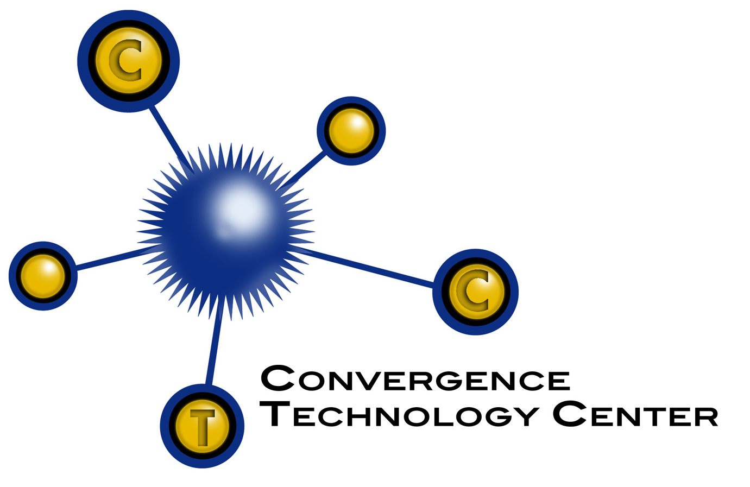 | Digital Home Technology Integration  Syllabus  Last revision date: 12/15/07  Course Number:
COURSE DESCRIPTION:
Integration and maintenance of various home technology subsystems. Includes home automation, security and surveillance, home networks, video and audio networks, and structured wiring.
PREREQUISITES: Completion of Introduction to Convergence Technologies course, and basic networking and troubleshooting skills or equivalent knowledge.
RESOURCES:

Home Technology Integration Fundamentals and Certification, Cisco Learning Institute, Pearson Education Inc., 2004 ISBN 0-13-114826-5

Lab Manual to accompany Home Technology Integration Fundamentals and Certification, Cisco Learning Institute, Pearson Education Inc., 2004 ISBN 0-13-142108-5
CD to accompany Home Technology Integration Fundamentals and Certification Kit, Cisco Learning Institute, Pearson Education Inc., 2004 ISBN 0-13-113410-8)
HTI Guide to Home Networking, Wells, Course Technology, 2004 ISBN 0-619-03547-1

HTI + Home Technology Integration, Wells, Course Technology, 2004 ISBN 1-59200-157-2

How to Automate both New and Existing Homes, Bucceri, Silent Servant, Inc., 2004
ISBN 0-9700057-3-3

Latest Technology in Automated Home Control, Bucceri, Silent Servant, Inc., 2004
ISBN 0-9700057-2-5

Complete Wiring, Meredith Books, 2003 ISBN 069621730-9
(ISBN 0-13-028486-6)

The Essential Guide to Telecommunications, 4th Edition, Annabel Z. Dodd, Prentice
Hall, 2005. (0-13-148725-6)

Residential Integrators Customer Relations, Terry Taylor, Thomson, 2007. (ISBN 1-4180-1413-3)

Residential Integrators Certification, Todd B. Adams, Thomson, 2007. (ISBN 1-4180-1409-5)

Residential Integrators Basics, Samuel DiPaola, Thomson, 2007. (ISBN 1-4180-1407-9)

Residential Integrators Project Management, Todd B. Adams & Gwen Wilson, Thomson, 2007. (ISBN 1-4980-1411-7)
WECM LEARNING OUTCOMES (Note WECM is Texas-specific – other states may want to include all objectives as merely objectives):
Upon successful completion of this course, the student will be able to do the following in today’s high tech home:

- Design, install, maintain, & integrate various subsystems for:
- Networking
- Audio/Video
- Telephony/VOIP
- Security & Surveillance Systems
- Home Control Management

ADDITIONAL LEARNING OUTCOMES RECOMMENDED:

- Apply current industry standards, codes and regulations to residential technology
- Configure basic home network systems to include
- Basic networking protocols
- Security
- Residential LAN
- Secure wireless
- Network cable characteristics
- Determine appropriate devices and components of audio/video systems for:
- Multi-room audio/video systems
- Residential home theater systems
- Content management systems
- Compare & contrast POTS vs. VOIP delivery
- Describe basic security terminology & apply installation procedures and methodologies for:
- Security panels
- Peripherals and accessories
- Access control devices and protocols
- Camera types and applications
- Define the fundamental characteristics and purpose of control systems which integrate subsystems in the home including:
- Device types
- Protocols and applications
- HVAC peripherals
- Basic lighting devices
- Power protection components

- Develop an understanding of basic concepts of project management including:
- Proposal
- Planning
- People
- Process
- Product
- Identify and apply the fundamentals of troubleshooting and diagnostics used in:
- Networking
- Audio/Video
- Telephony/VOIP
- Security & Surveillance Systems
- Home Control Management

SUGGESTED COURSE ASSESSMENT:

Class lectures/PowerPoints will cover and expand upon the assigned reading material.
Labs will be used for hands-on experience. Regularly scheduled quizzes, tests, and exams will be administered by your instructor. Assignments, suggested schedules, and supplementary material to be distributed on the first day of class and posted to an online site provided by your instructor.

Learning Activity Projects/Skills Exams | 20% |  | Grade Values:
Midterm Exam | 10% |  | A= | 90-100
Learning Activity Assessments | 30% |  | B= | 80-89
Final Exam | 30% |  | C= | 70-79
Class participation/  Daily Work | 10% |  | D= | 60-69
Final Grade | 100% |  | F= | 59-Below

COURSE SCHEDULE: (Sequence of instruction recommended based on learning outcomes)
Week | Learning Outcome | Learning Activity/Assessment
1 | 2  Apply current industry standards, codes and regulations to residential technology | Lecture: Standard codes and regulations  Learning Activity Assessment: Assessment 1  Learning Activity: NFPA Annex B Lab
2  3  4 | 1  Design, install, maintain, & integrate various subsystems for:  - Networking  - Audio/Video  - Telephony/VOIP  - Security & Surveillance Systems  - Home Control Management  3  Configure basic home network system to include:  - Basic networking protocols  - Security  - Residential LAN  - Secure wireless  - Network cable characteristics  9  Identify and apply the fundamentals of troubleshooting and diagnostics used in:  - Networking  - Audio/Video  - Telephony/VOIP  - Security & Surveillance systems  - Home Control Management | Lecture: Networking  Learning Assessment: Assessment 2  Learning Activity: Installation tools, Straight-thru cable, Cross-over cable, Cable testing, Connect two computers, Connect to Internet, Create data jack, Cable distribution, Antivirus install, Configure a firewall, Port configuration, Configure wireless security
5  6 | 1  Design, install, maintain, & integrate various subsystems for:  - Networking  - Audio/Video  - Telephony/VOIP  - Security & Surveillance System  - Home Control Management  4  Determine appropriate devices and components of audio/video systems for:  - Multi-room audio/video systems  - Residential home theater systems  - Content management systems  9  Identify and apply the fundamentals of troubleshooting and diagnostics used in:  - Networking  - Audio/Video  - Telephony/VOIP  - Security & Surveillance Systems  - Home Control Management | Lecture: Audio & Video  Learning Assessment: Assessment 3  Learning Activity:
7  8 | 1  Design, install, maintain, & integrate various subsystems for:  - Networking  - Audio/Video  - Telephony/VOIP  - Security & Surveillance Systems  - Home Control Management  5  Compare & contrast POTS vs. VOIP delivery  9  Identify and apply the fundamentals of troubleshooting and diagnostics used in:  - Networking  - Audio/Video  - Telephony/VOIP  - Security & Surveillance Systems  - Home Control Management | Lecture: Telephony/VOIP  Learning Assessment:  Assessment 4  Learning Activity:
9 | Mid-Term | Mid-Term Exam  Assessment 5

10  11 | 1  Design, install, maintain, & integrate various subsystems for:  - Networking  - Audio/Video  - Telephony/VOIP  - Security & Surveillance Systems  - Home Control Management  6  Describe basic security terminology & apply installation procedures and methodologies for:  - Security panels  - Peripherals and accessories  - Access control devices and protocols  - Camera types and applications  9  Identify and apply the fundamentals of troubleshooting and diagnostics used in:  - Networking  - Audio/Video  - Telephony/VOIP  - Security & Surveillance Systems  - Home Control Management | Lecture: Security & Surveillance System  Learning Assessment:  Assessment 6  Learning Activity: Install outdoor camera and integrate with existing services, Direct camera monitoring, RJ31X design, Surveillance camera installation
12  13 | 1  Design, install, maintain, & integrate various subsystems for:  - Networking  - Audio/Video  - Telephony/VOIP  - Security & Surveillance Systems  - Home Control Management  7  Define the functionality, characteristics and purpose of control systems which integrate subsystems in the home including:  - Device types  - Protocols and applications  - HVAC peripherals  - Basic lighting devices  - Power protection Components  9  Identify and apply the fundamentals of troubleshooting and diagnostics used in:  - Networking  - Audio/Video  - Telephony/VOIP  - Security & Surveillance Systems  - Home Control Management | Lecture: Home Control Management  Learning Assessment:  Assessment 7  Learning Activity: Connect devices to HAI OmniLT, Scene lighting control setup, HVAC layout
14 | 8  Develop an understanding of basic concepts of project management including:  - Proposal  - Planning  - People  - Process  - Product | Lecture: Project Management  Learning Assessment:  Assessment 8  Learning Activity: Create basic customer job proposal
15 | Finals Week | Final Exam & Skills Exam  Assessment 9 & 10

ACKNOWLEDGEMENTS

Syllabus developed by: Julian Carranza, faculty member of El Centro College and Eliazar Martinez, faculty member of El Centro College. This syllabus was developed with support from National Science Foundation. Project leader was Bette Plog, Co-PI for the NSF ATE grant 0402356.

Non-exclusive copyright © 2007. Non-exclusive copyright is retained by Collin County Community College on behalf of the National Science Foundation ATE Grant 0402356. Any opinions, findings, and conclusions or recommendations expressed in this material are those of the author(s) and do not necessarily reflect the views of the National Science Foundation

