How to Download the “Packaged” Updated KSA List as a Google Sheet and Google Form
August 2020

Using free online Google tools will automate the collecting and tallying of BILT member votes, making the KSA meeting run more efficiently and allowing more time for discussion.

The CTC has converted the summer 2020 updated KSA list into a Google Sheet and created a corresponding, linked Google Form that your BILT members can use to vote. Once you’ve downloaded your own personal, local copy of the Sheet and the Form, you may edit both as needed.

Learn more about using Google tools for your KSA vote:
Video - http://bit.ly/KSAVideo
Document - https://bit.ly/GoogleKSA

1. Open this link to access the KSA Google Sheet:
https://docs.google.com/spreadsheets/d/1fv-NslqeRJALD9sxuMJP4jZUy-nrI-eSXEI0R7T-dLk/copy

2. You will be asked to log into your Google account.

3. Once you’re logged into Google, you will be asked to click a big blue “Make a copy” button.

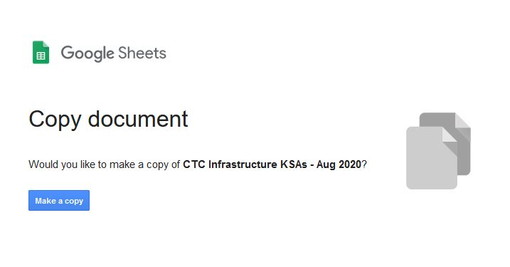

4. After you click that blue “Make a Copy” button, the KSA Google Sheet will open and load into your Google Drive. This is your local copy of the KSA list to edit and update as needed. Remember you’ll likely need to make some changes to the text during the KSA meeting discussion as directed by your BILT.

5. To open the linked Google Form for your BILT members to use to vote, go to the “Form” pull-down menu on the Google Sheet and select “Go to Live Form.”

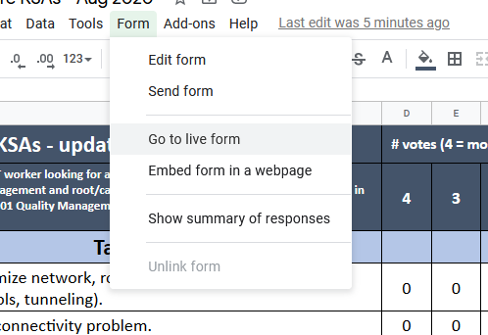

6. After you select “Go to Live Form,” the KSA Google Form will open and load into your Google Drive alongside the KSA Google Sheet. This is your local copy of the form, linked to the KSA Google Sheet.

Votes cast with this form – which you’ll send out to your BILT members – will be recorded in the KSA Google Sheet using the usual KSA averaging formulas. Using the pencil icon in the lower right, you will be able edit and update the form as needed. (Just be careful of making changes that might affect the formulas and calculations on the KSA Google Sheet.)

7. Verify that both the KSA Google Sheet and the KSA Google Form are in your Google Drive.

If you use the Google tools for your BILT meeting, please let us know how it goes!

More resources

“Your Annual Job Skills Validation Vote” webinar (10 minutes), http://bit.ly/jobskillsvote

“Setting Up Google Form and Spreadsheet for KSA Voting” document, https://bit.ly/GoogleKSA
* Pages 11-14 explain how to share the Form with your respondents (and test it before you send to your BILT)
* Pages 15-16 explain how to adjust the “Settings” so your BILT members will receive a copy of their vote and also allow them to re-vote online

“Using Google Tools to Tally and Average Your KSA Vote” webinar (21 minutes), http://bit.ly/KSAVideo

