How to Download and Use the Updated KSA List as a Google Form
August 2021

Using free online Google tools will automate the collecting and tallying of BILT member votes, making the KSA meeting run more efficiently and allowing more time for discussion.

The CTC has converted the summer 2021 updated KSA list into a Google Form that your BILT members can use to vote. Once you’ve downloaded your own personal, local copy of the Form, you will create the Google Sheet.

Learn more about using Google tools for your KSA vote:
- To watch a tutorial that demonstrates the steps of this document, visit: http://bit.ly/GoogleKSAsheet.
- For a deeper dive into creating Google Forms and Google Sheets “from scratch” without the aid of an existing KSA survey, visit: bit.ly/onlineKSAvote .

Creating a Local Copy of the Google Form

1. Open this link to access the KSA Google Form:
https://docs.google.com/forms/d/18VuPjT5AU_RBhCEEhFtWNmZ0Nx7ITA8_IEUn_ZlXmxQ/copy

2. You will be asked to log into your Google account.

3. Once you’re logged into Google, you will be asked to click a big blue “Make a copy” button.

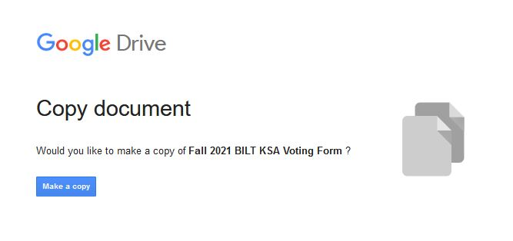

4. After you click that blue “Make a Copy” button, the KSA Google Form will open and load into your Google Drive. This is your local copy of the KSA list to edit and update as needed. If you have questions or KSAs you want to add to the CTC list now is the time to make them by updating amending the Google Form.

Linking the Google Form to the Google Sheet

Now it’s time to connect the Google Form (which will collect the BILT voting results) to a Google spreadsheet.

Inside the Google Form page, click on the “Responses” tab in the Form menu header (it’s to the right of the “Questions” tab you’re working in now), then click on the three vertical dots. From there, click “Select response destination.”
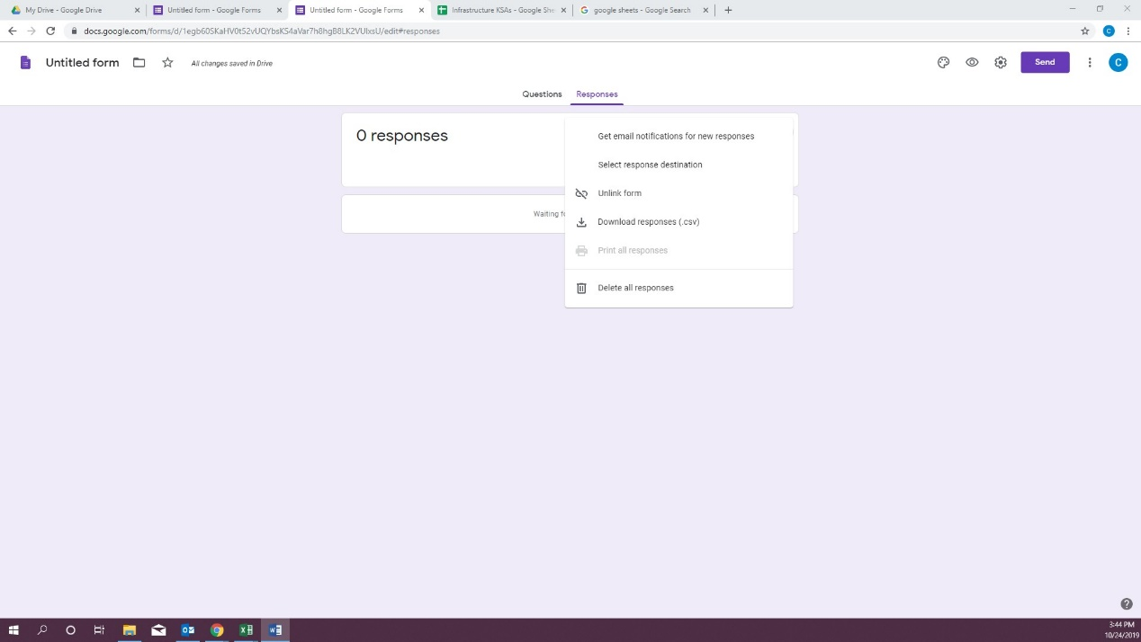

In the new “Select response destination” window click on “Create a new spreadsheet,” then click “Create.”

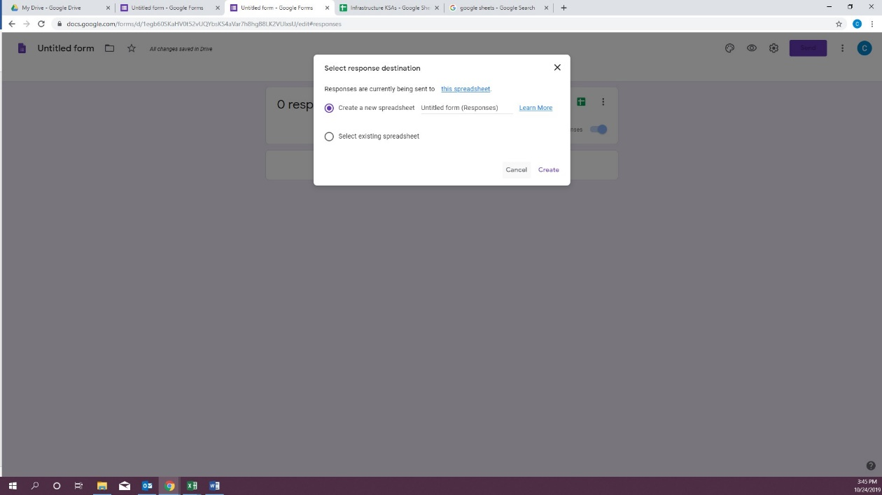
Messages will pop up in the bottom left corner letting you know that the form and the spreadsheet are linking.

Next, go back to “My Drive,” under files you will find a “Google Sheet” titled the same thing as your survey double click on it to open it.
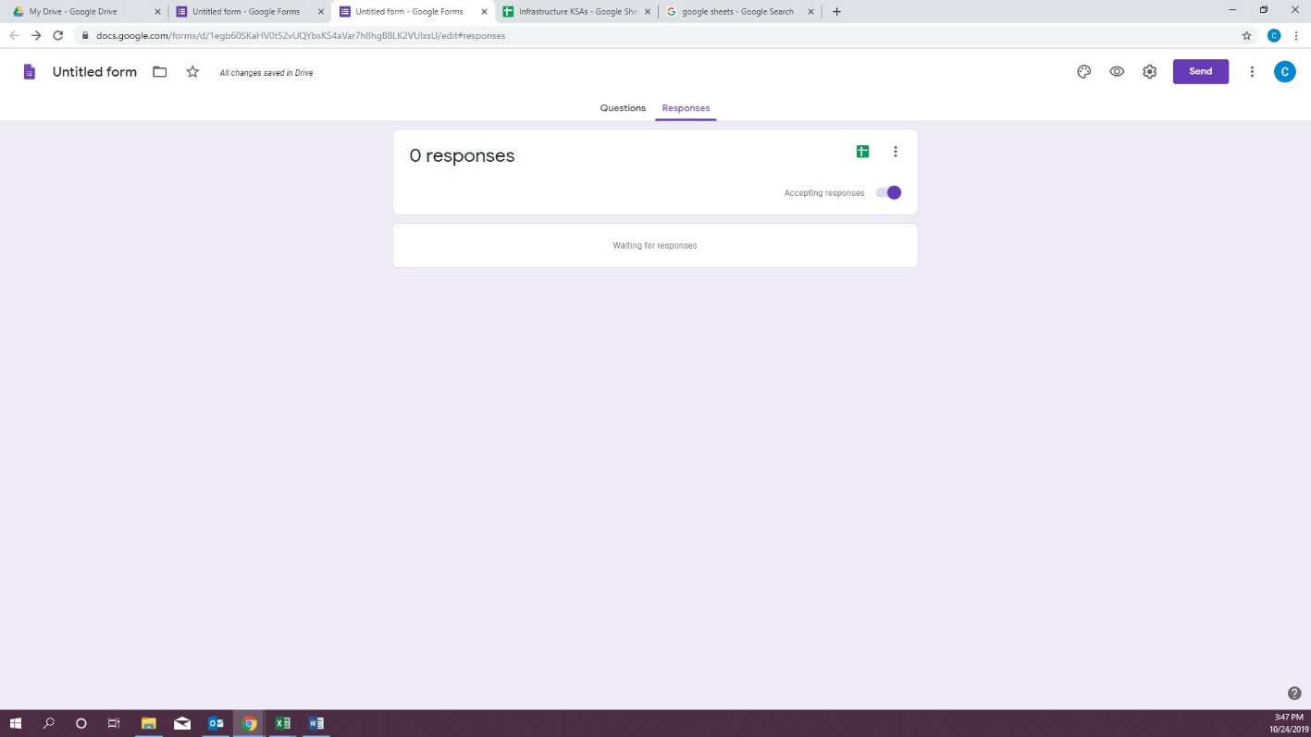

Now you will notice there is a tab on your Google Sheet titled “Form Responses 1.”

Click on this new “Form Responses 1” tab (beside the “Sheet1” worksheet tab that created earlier) and you should see you questions from your Google Form across row 1.

- Configuring the Vote Tabulation

To set up KSA sheet with the vote tally, go to the Google Sheet “KSA Summary Template” at the link below. There are two tabs in that Google Sheet. “KSA” is the template you will copy. The other “Instructions for use” tab provides additional directions for how to use the template. Please note the sum column in this template will be black until votes are entered.

https://docs.google.com/spreadsheets/d/1v7CoXaG7HmfnWcl_6H5RjRhHKGoMu6mhcPnIewXgzYE/edit?usp=sharing

Here are the six steps to follow:

- Using the link above, open this “KSA Summary Template” Google Sheet. This will open as a new tab in your browser. Make sure that you click on the tab labeled “KSA.” Right-click the “KSA” sheet tab, select “Copy to” and “Existing spreadsheet,” then select the Google Sheet file created in Section II and click select. Then click on the Google Sheet browser tab and note the added "Copy of KSA" tab next to your “Form Responses 1” tab.

- In the “Form Responses 1” tab of your Google Sheet (which in our example we’re calling “Infrastructure KSAs”), select all of row 1 by clicking on the number 1. The entire row should be highlighted. Right click on the highlighted row 1 and select Copy.

- In the Copy of KSA tab, select cell A1, right click to open up a menu. Select “Paste special” and then select “Paste transposed.”

- Select cells B4 thru I4, double click the tiny blue square in the lower right corner of the selected cells (this tiny square will automatically replicate the formula all the way down to the last row).

- Select columns B & C, right click on the selected columns and select “Copy.” Then you will right click again in the highlighted selected columns, select “Paste special” then select “Paste values only.”

- Remove column A by selecting all of column A right click on the highlighted column, right click and select delete column.

When you are finished it should look like the screenshot below.

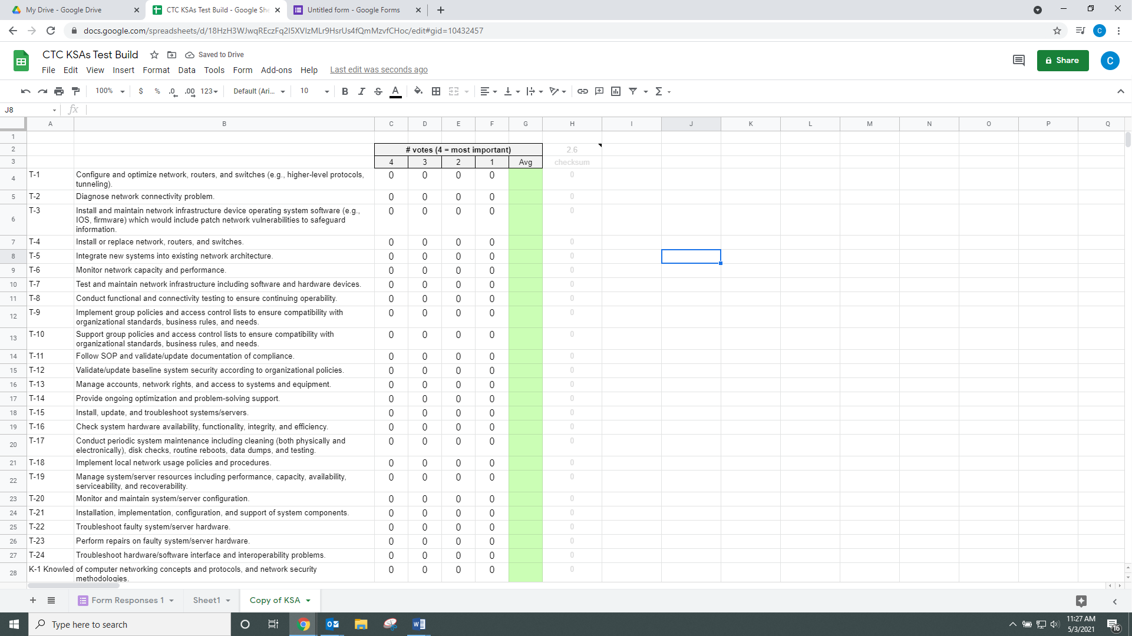

Testing the Form

Now you are ready to have someone test the Google form. Thorough testing is strongly encouraged before you use the Google voting system with your BILT.

Go up to the tabs in your web browser and click on Google Form:
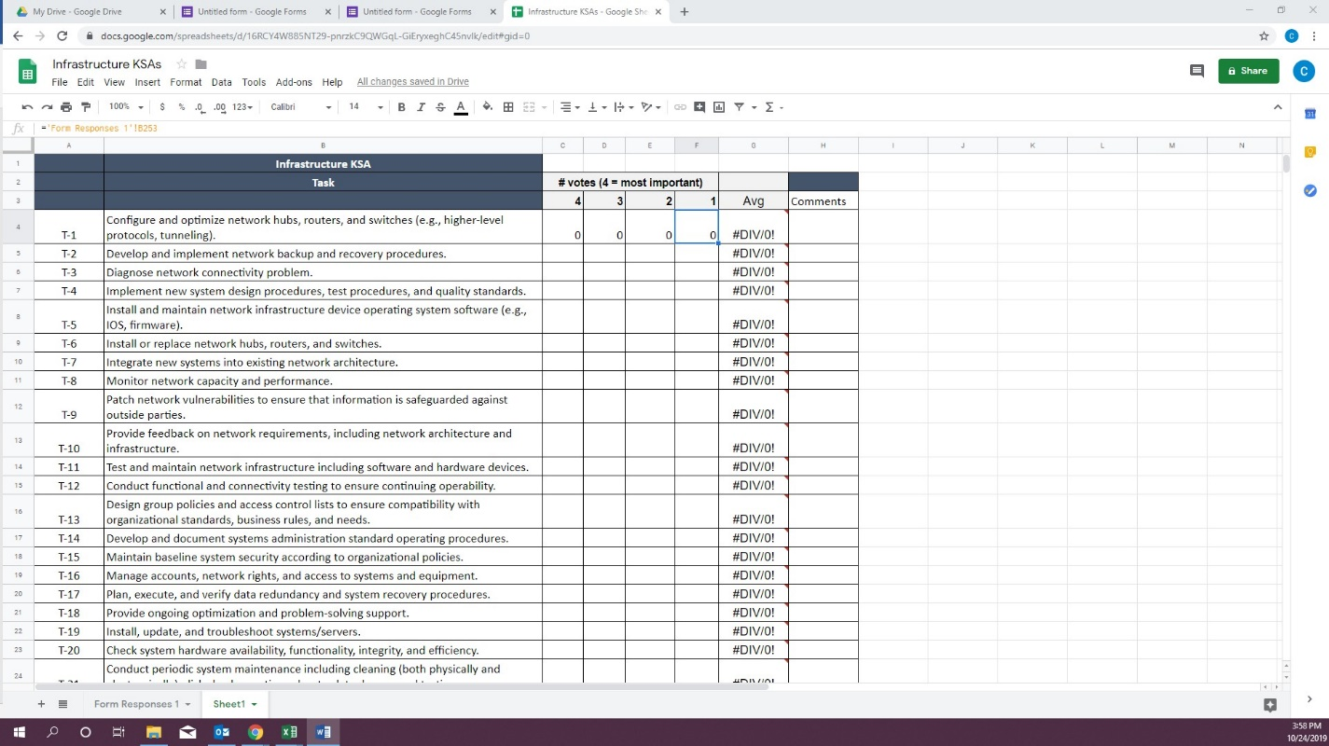

Click on the purple send button at the top right of the screen:
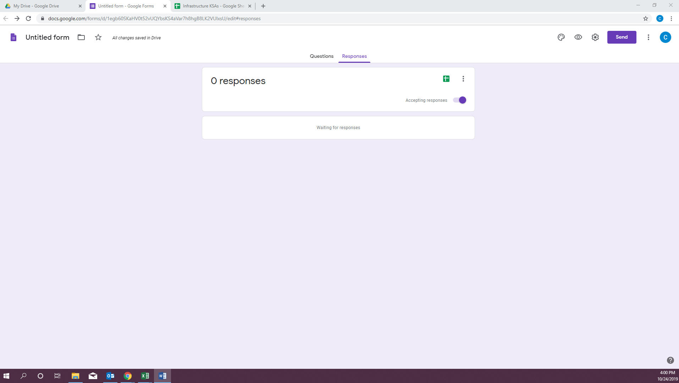

Click on the weblink icon (it looks like a chain). That will create a shareable link to this form (notice that under that link is a box you can click to shorten the URL).
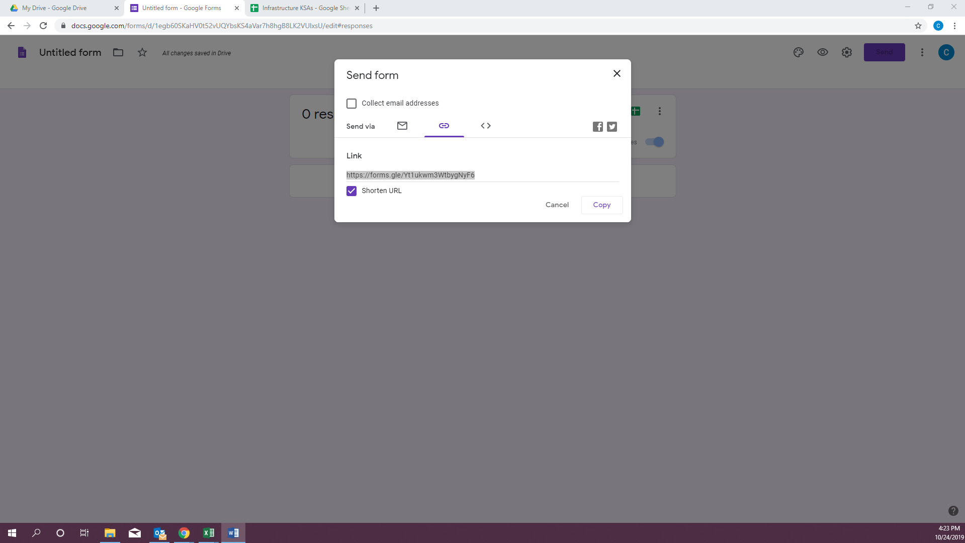

Send that form link URL to someone else and ask them to use it in a new browser and complete the Google Form.

Now go back to “Infrastructure KSAs” Google Sheet:
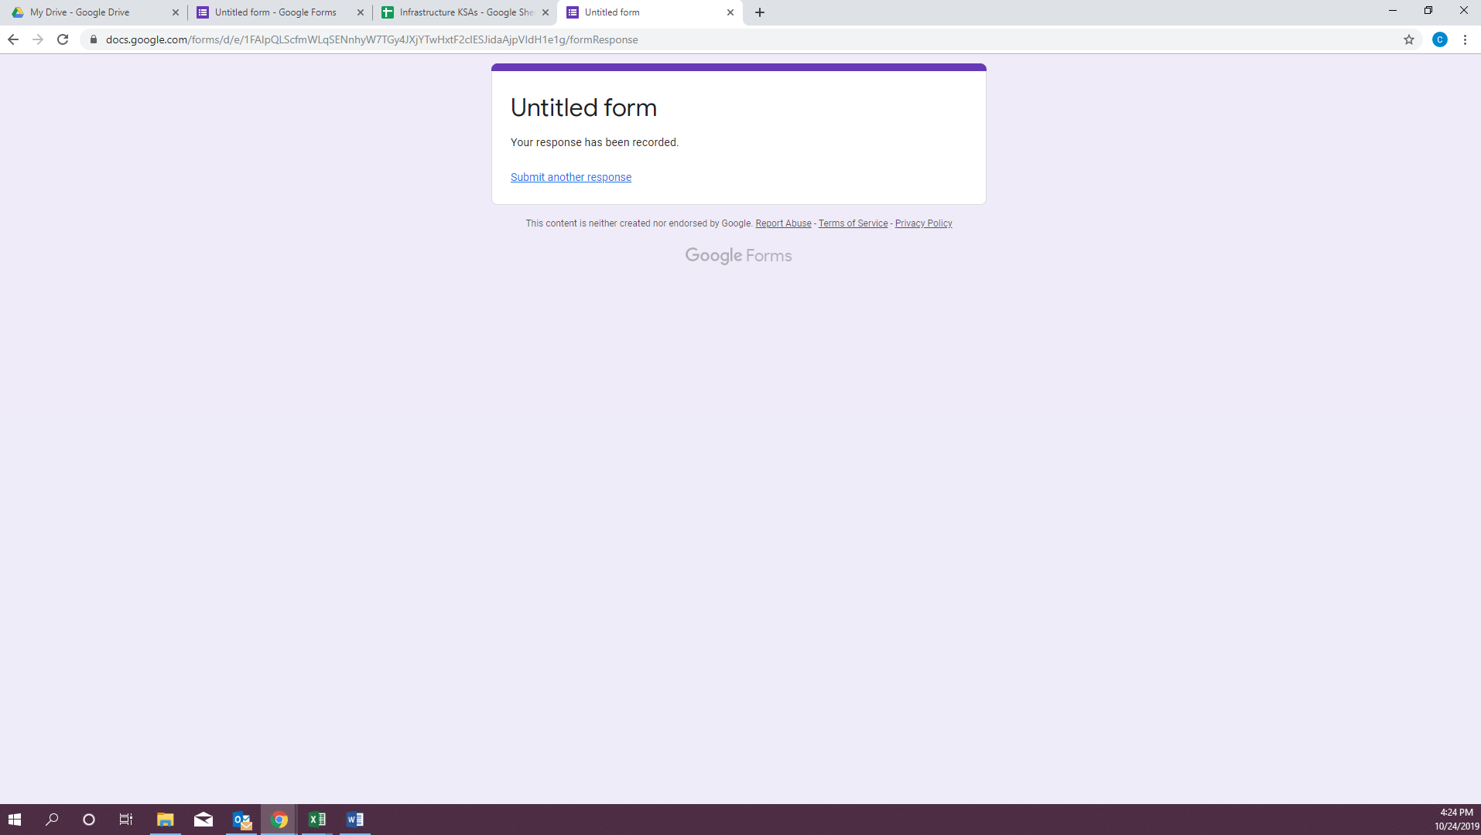

If done correctly you should see the test votes show up in your form:

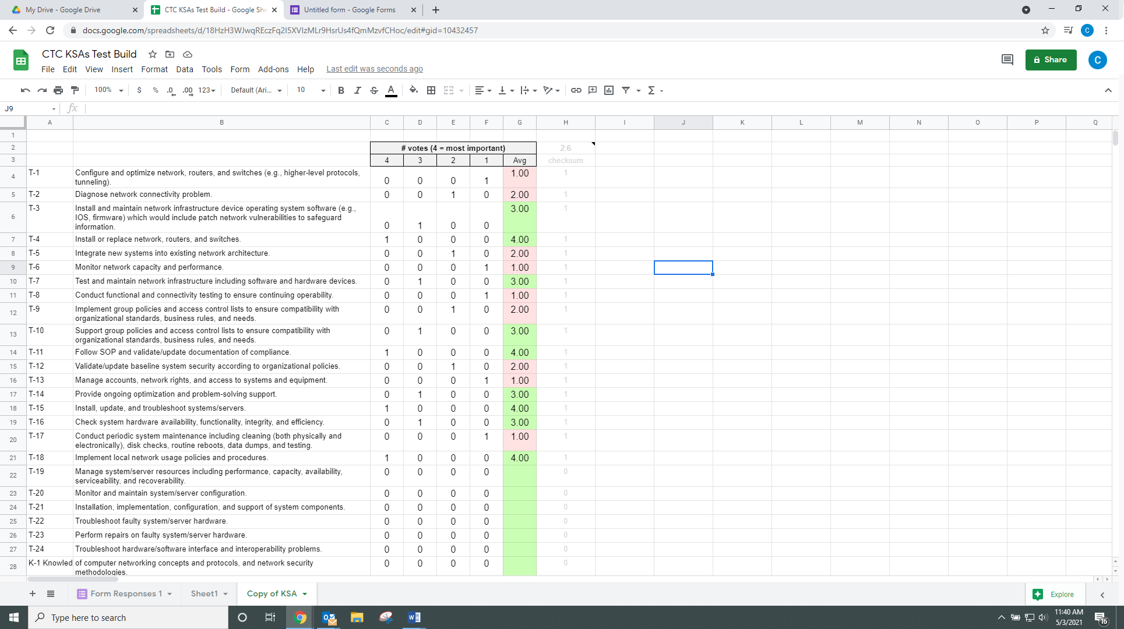

If that is reflecting correctly, then congratulations ‐ you have finished!

BUT… if the numbers don’t look right, go back and ensure you followed the six steps in Section III for using the template.

This material is based upon work supported by the National Science Foundation under Grants No. 1700530 and 1838535. Any opinions, findings and conclusions or recommendations expressed in this material are those of the author(s) and do not necessarily reflect the views of the National Science Foundation.

This work is licensed under Creative Commons Attribution 4.0.
https://creativecommons.org/licenses/by/4.0/

